Q1:

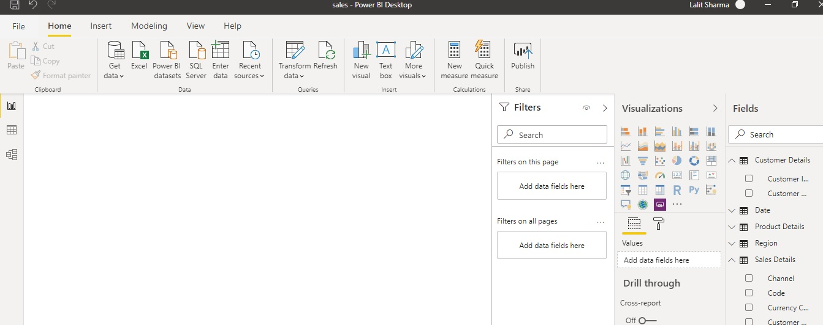

Q 2 a): Report View: Screen shot above

Power BI Desktop includes a Report view, where you can create any number of report pages with visualizations. Report view in Power BI Desktop provides a similar design experience to the report's editing view in the Power BI service. You can move visualizations around, copy and paste, merge, and so on.

b): Data View: Data view helps you inspect, explore, and understand data in your Power BI Desktop model. It's different from how you view tables, columns, and data in Power Query Editor. With Data view, you're looking at your data after it has been loaded into the model.

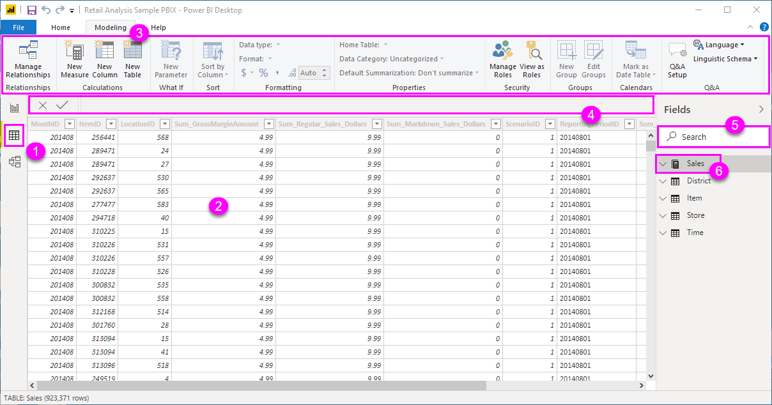

C: − Model View: With **Modeling view** in **Power BI Desktop**, you can view and work with complex datasets that contain many tables.

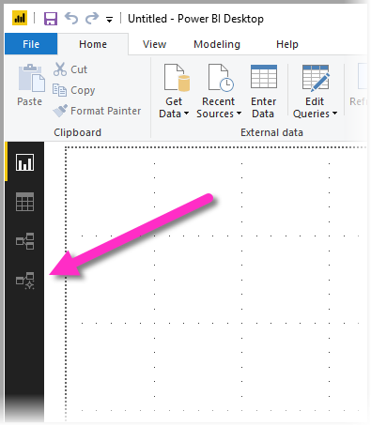

D: − Power Query Editor:

**Power Query** is made available in **Power BI Desktop** through **Power Query Editor**. To launch Power Query Editor, select **Edit Queries** from the **Home** tab of Power BI Desktop.

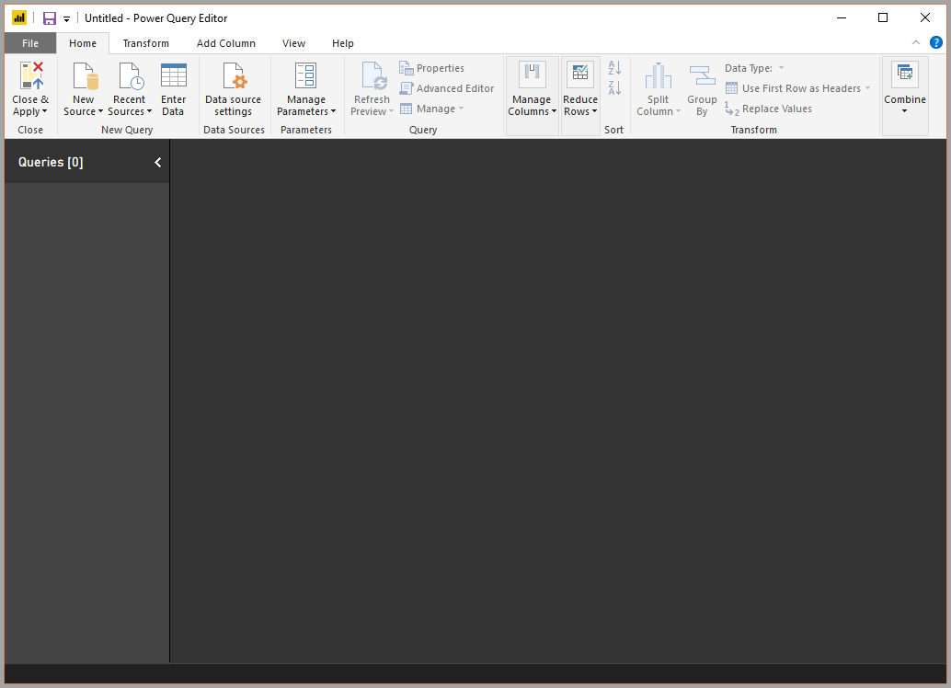

E: − Advance Editor:

In **Power BI**, when we add data using Get Data button by connecting to the services, **Power BI** generates a **query** in background and we can modify this **query** and its data sources using '**Advanced Editor**' Button.

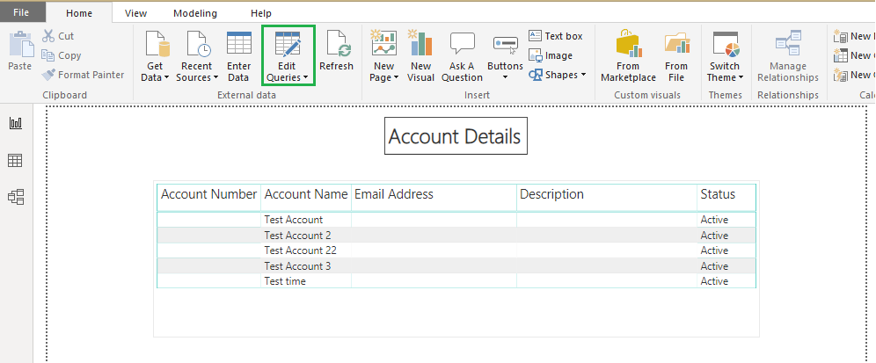

Q3:

* **Power BI Desktop**: This offering is free to any single user and includes data cleaning and preparation, custom visualizations and the ability to publish to the Power BI service.
* **Power BI Pro**: The Pro plan costs $9.99/user/month. It includes data collaboration, data governance, building dashboards with a 360-degree real-time view and the ability to publish reports anywhere. Users can try it a free trial for 60 days before purchasing the subscription.
* **Power BI Premium:** The Premium plan starts at $4,995 a month per dedicated cloud compute and storage resource.

Power BI Desktop includes a Report view, where you can create any number of report pages with visualizations. Report view in Power BI Desktop provides a similar design experience to the report's editing view in the Power BI service. You can move visualizations around, copy and paste, merge, and so on.